**Boston University**

**Electrical & Computer Engineering**

**ClearSol**

**Final Test Report**

By Team 29

ClearSol

Team Members

Fabio Amado [famado@bu.edu](mailto:famado@bu.edu)

Zachary Capone [zcapone@bu.edu](mailto:zcapone@bu.edu)

Julian Leguizamon [julianle@bu.edu](mailto:julianle@bu.edu)

Ryan Rosenberger [rjrose@bu.edu](mailto:rjrose@bu.edu)

Anthony Saab [saabanth@bu.edu](mailto:saabanth@bu.edu)

**Required Material:**

Hardware:

* Solar Panel Assembly & High Power LED Light
* 6V DC Power Supply (AC adapter)
* 18V DC Power Supply (Bench power supply)
* Monitoring Control Circuit
  + Raspberry Pi
  + 4 INA260 Power Sensors
  + Relay HAT
* Display/UI
  + Switches/Button Panel
  + 7 Segment LCD Display
* Assembled power circuit
  + Buck Converter
  + Supercapacitor Charge Controller
  + 4 400F supercapacitors
  + Primary boost converter
  + Secondary boost converter
  + Load resistor bank (EDS simulation)

Software:

* Python:
  + Gets data from INA260 Power Sensors
  + Initializes LCD Display and prints voltage and current data
  + Reads from the GPIO pins to determine the position of switch for the EDS
  + Activates the relay to turn on and off the simulated EDS load

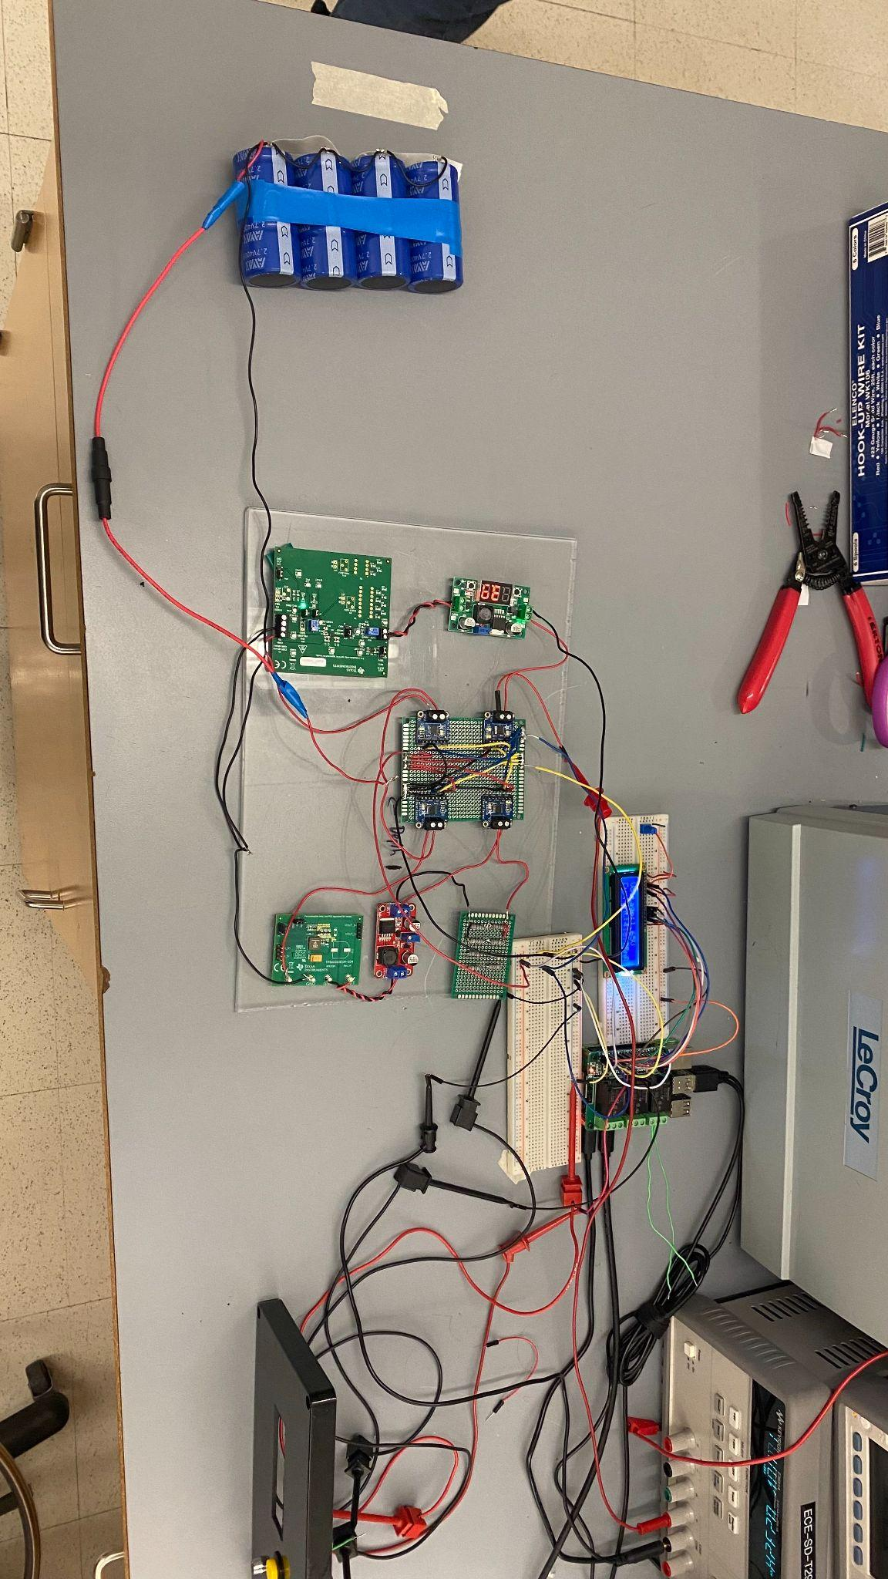

***Figure 1: Our wired up system ready for testing***

**Set-Up:**

The goal of this test is twofold: demonstrating the functionality of the power system and the functionality of the monitoring/control system. We aim to showcase these systems simultaneously, as our supercapacitors are charged and discharged.

First, we will demonstrate how our supercapacitor storage bank can be charged using a connected solar panel. The monitoring system will display both the solar panel voltage and output current, and the supercapacitor voltage and input current.

Second, we will demonstrate how the energy stored in our supercapacitor bank can be converted to supply an EDS-like load. The monitoring/control system will activate the load side of the power circuit when a user flips a switch. The monitoring system can then show the supercapacitor voltage and discharge current, and the load voltage and output current to the load.

The essence of our prototype testing is to utilize the circuit we currently have assembled as well as demonstrate activation of the circuit through both power coming in from the solar panel (as demonstrated with our high wattage LED lamp) as well as with a direct supply of power fed into the circuit through our power supply.

**Pre-Testing Procedure:**

1. Ensure that the physical circuit is laid out neatly on the table so that all connections and components are clearly visible.
2. Connect an 18V DC power supply to the input of the power circuit.
3. Precharge the supercapacitor bank to 2.5V.
4. Place the solar panel assembly beneath the LED lamp.
5. Disconnect DC power supply from power circuit input, and connect solar panel to power circuit input.
6. Boot python in the Raspberry Pi for switch demonstration.
7. By repeatedly long pressing the button on the control panel, cycle the measurement display until the solar panel measurements are displayed.

**Testing Procedure:**

1. Activate the LED lamp and adjust it to its brightest setting.
2. Observe the power readings associated with the solar panel. Verify that the panel is operating at a reasonable output voltage, and that it is supplying current to the power circuit.
3. Cycle the measurement display until the supercapacitor input measurements are displayed.
4. Observe the power readings associated with the supercapacitor input. Verify that the supercapacitors are receiving current from the charger, and that the supercapacitor voltage is increasing.
5. Turn off the LED light.
6. Cycle the measurement display until the solar panel measurements are displayed.
7. Verify that the solar panel is not supplying significant current to the power circuit.
8. Cycle the measurement display until the supercapacitor output measurements are displayed.
9. Observe the supercapacitor voltage, and verify that the supercapacitors are not discharging.
10. Turn on the EDS load by flipping the switch.
11. Observe the supercapacitor discharge current, and verify that the supercapacitors are now discharging.
12. Cycle the measurement display until the load measurements are displayed.
13. Observe the load measurements. Verify that the load is being supplied with a voltage of 12V, and that roughly 1.3W are being consumed by the load.

**Measuring Criteria**

The criteria for successful running and output is as follows:

1. The monitoring system is able to display voltage and current measured by all four power sensors.
2. The supercapacitors charge when connected to the illuminated solar panel.
3. The supercapacitors discharge and supply adequate power to the load when triggered by a user.

**Score Sheet**

| Expected Behavior | Observed? |
| --- | --- |
| Supercapacitors charge when connected to illuminated solar panel | Yes |
| Supercapacitors discharge and supply power to load when load is turned on by user | Yes |
| Measurement system displays power measurements for all four sensors | Yes |

**Detailed Measurements**

Our observations and measurements were primarily quantitative, as the goal of this test was to ensure basic functionality of the power and measurement systems as opposed to reaching any specific performance targets. That being said, there were a few key measurements that we took during the test.

For the load, we measured the supply voltage that was applied to the load to be 12V. This meets our supply requirements. We observed a load current of roughly 70mA. This results in a power draw of roughly 0.8W, which is less than the target of 1.32W. This is due to an incorrect load resistance value, which we will rectify in our subsequent work.

For the solar panel, we measured an output voltage of approximately 19.6V and an output current of roughly 70mA. This is an interesting result, because this voltage is higher than the listed maximum power point voltage of our panel (18.0V). This suggests that we could potentially further optimize our charge current to extract more power from the panel. This could potentially decrease our supercapacitor charge time when connected to the solar panel.

For the supercapacitors, we measured a charge current to the supercapacitors of 200mA, and a supercapacitor voltage (at the beginning of the test) of roughly 2.5V. This showed that our charge current was properly limited to 200mA, and that the supercapacitors were successfully being charged.

**Conclusion**

By successfully accomplishing all of our goals in our testing plan we were able to demonstrate a fully functioning system that accomplishes the entire scope of our project. We will be able to demonstrate supercapacitor charging when hooked up to our solar panel, supercapacitor discharge to supply our EDS load and a monitoring and control system to regulate and monitor different measurements around our system.

The testing plan proves that the project fulfills all of its functional requirements. The system is able to run completely independently with a supercap storage system, microcontroller, and an EDS dummy load. The capacitance works for the smaller scale of our project and can be improved to accommodate larger scales.

This test also highlights next steps between now and project completion. For the power system, load adjustment, charge optimization, and charge/discharge profiling are needed. For the monitoring system, some UI streamlining and logging functionality will be implemented.